Akansha Chowdhury

Extract, Transform, and Load Certification Training
Course-End Project-1

Retail Data Management
The AWS Console was logged in and the location was set to at North Virginia (USA)
The S3 bucket was created where the bucket name was used as etl-cep-01-15 (date of doing the project – 15/10/2025) in place of etl-cep-01 as it was already used.
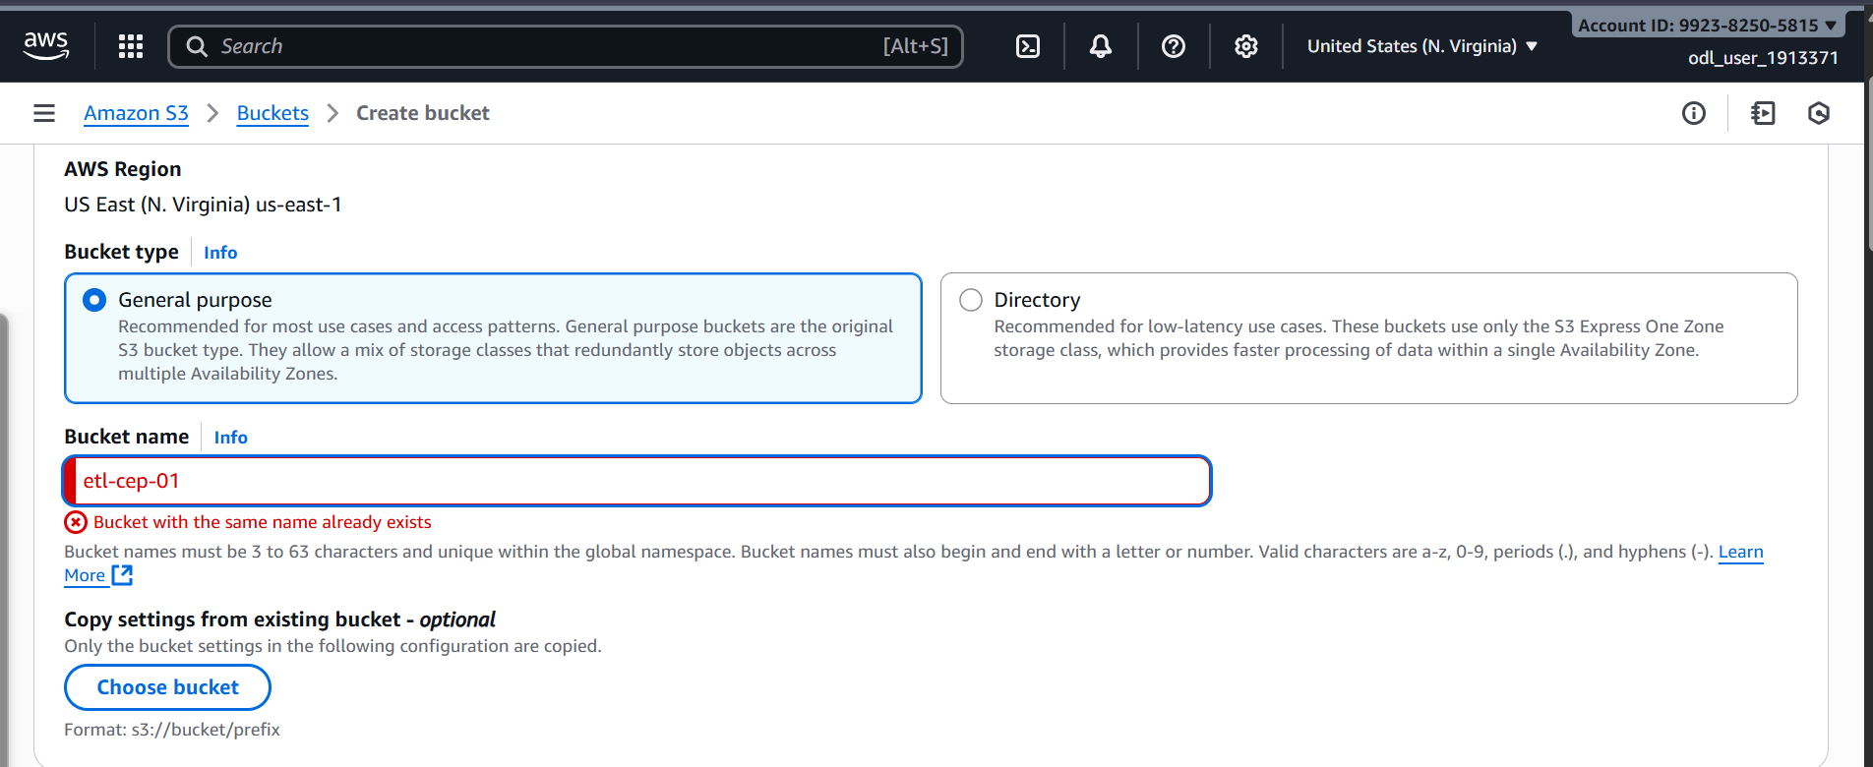
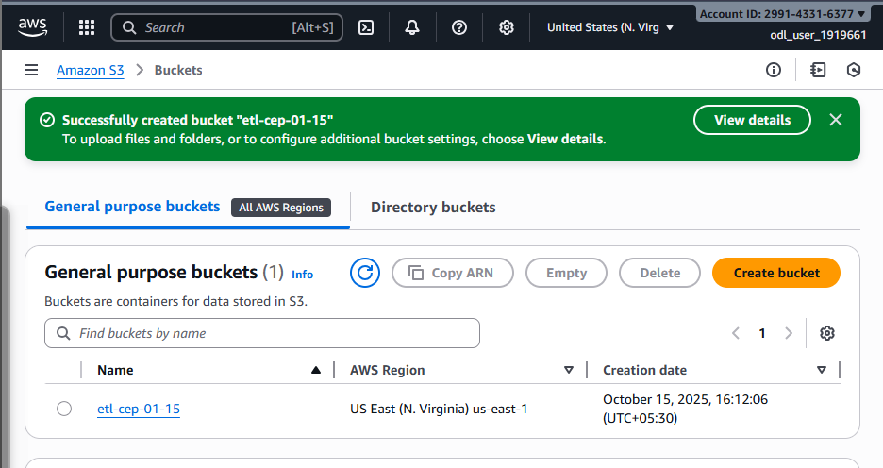
Next the two folders were made respectively transaction-files and product-files
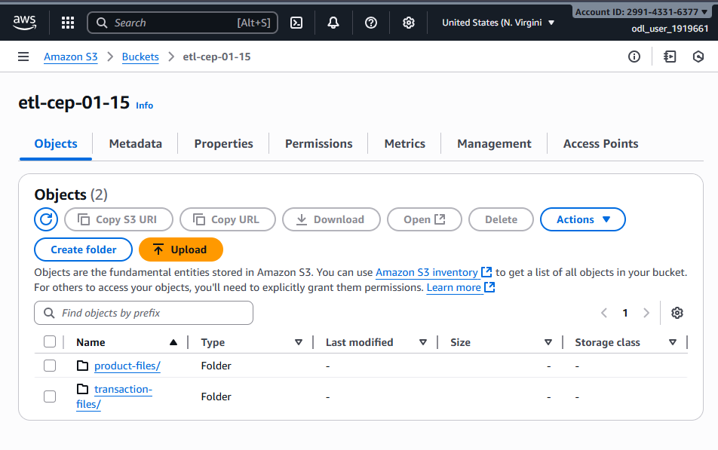
Inside those folders the files were uploaded
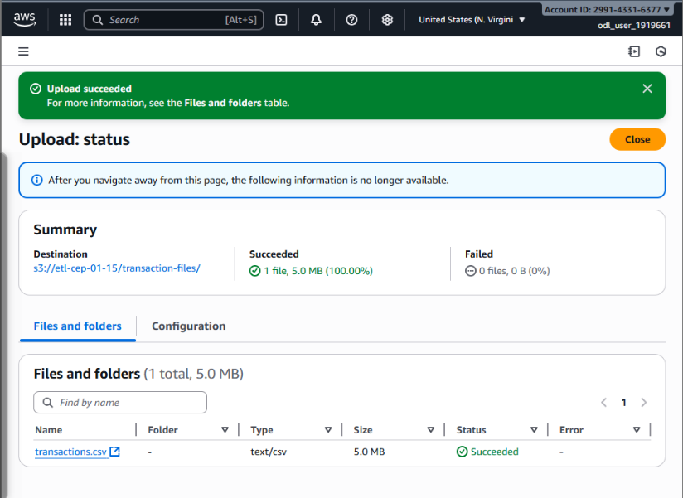
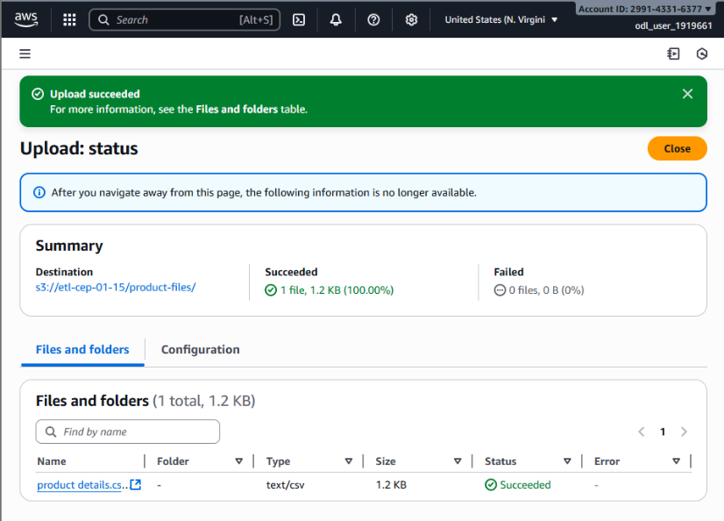
After that the next bucket was made and the name was changed as it said name already used. So, the new bucket was named etl-cep-output-01-15
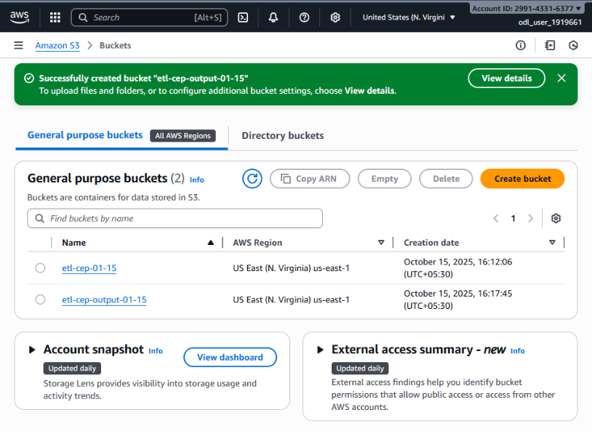
A new database was created abc-retail in the AWS Glue console
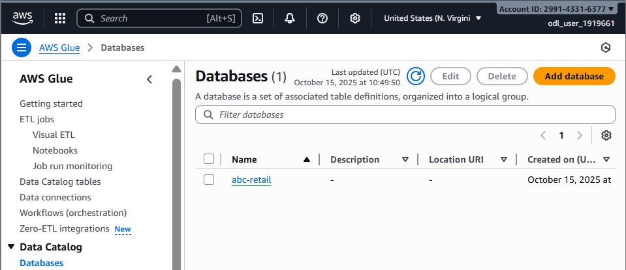
The two classifiers were created based on the give instructions
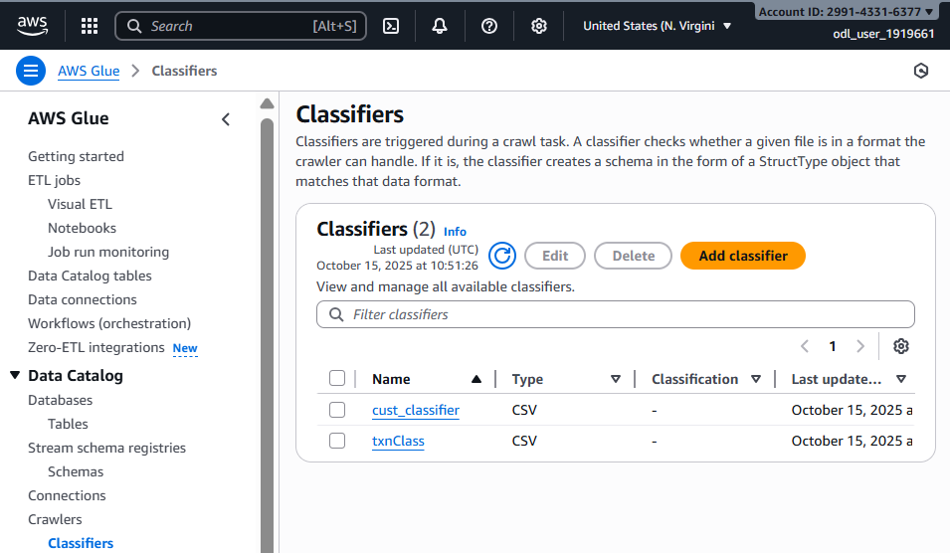
The new role was created in IAM role as glue-role
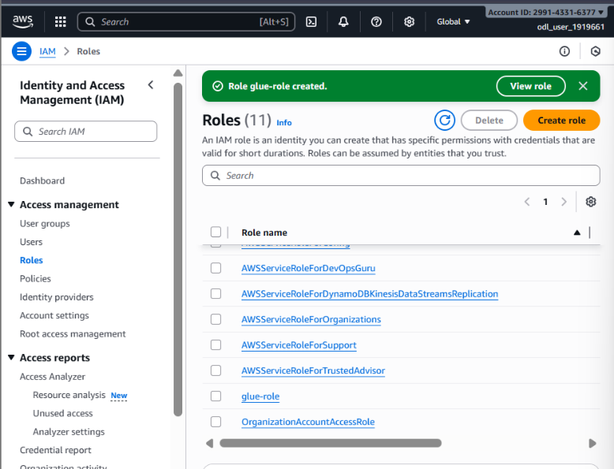
The Crawler was set up for both datasets
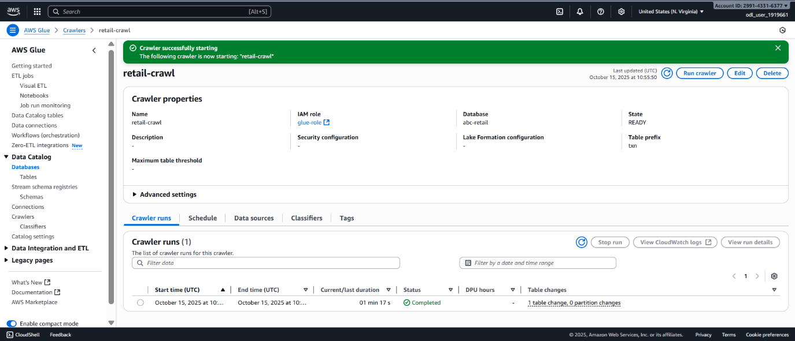
For the second crawler, the name was set as retail-crawl_15 as it was not accepting the same name
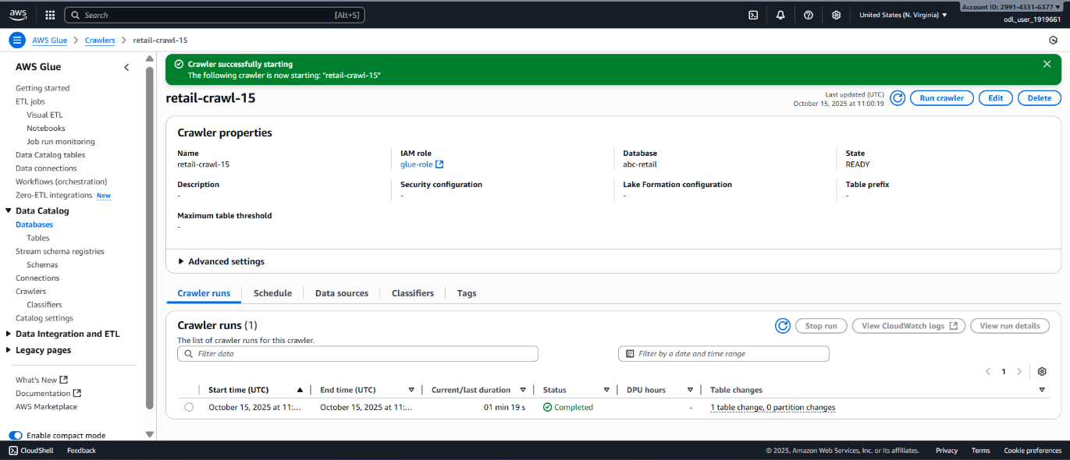
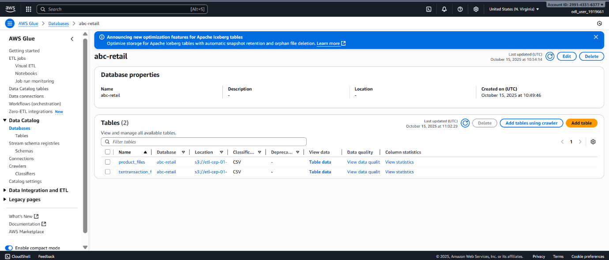
The ETL Job were created
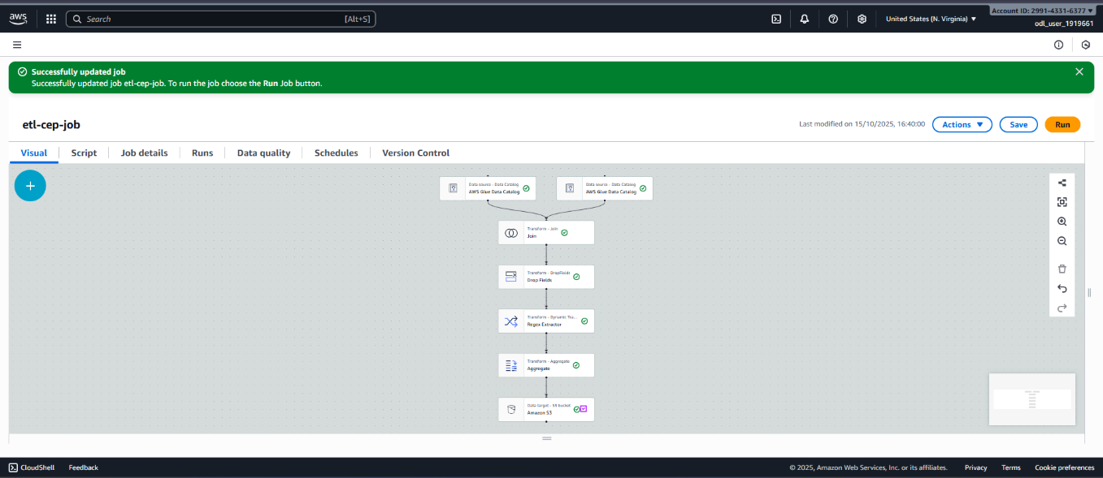
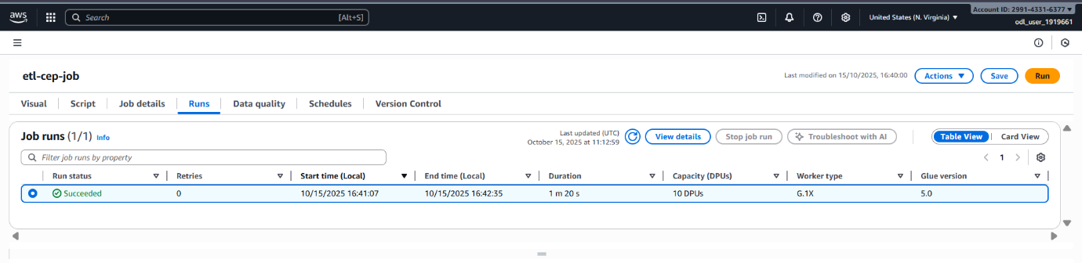
To check the output
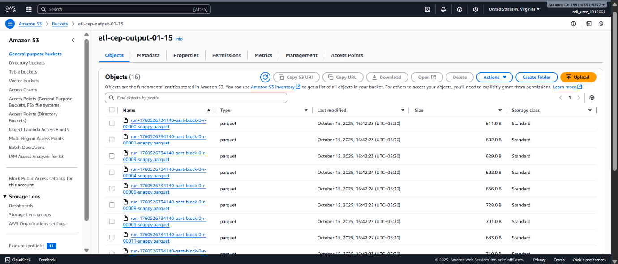

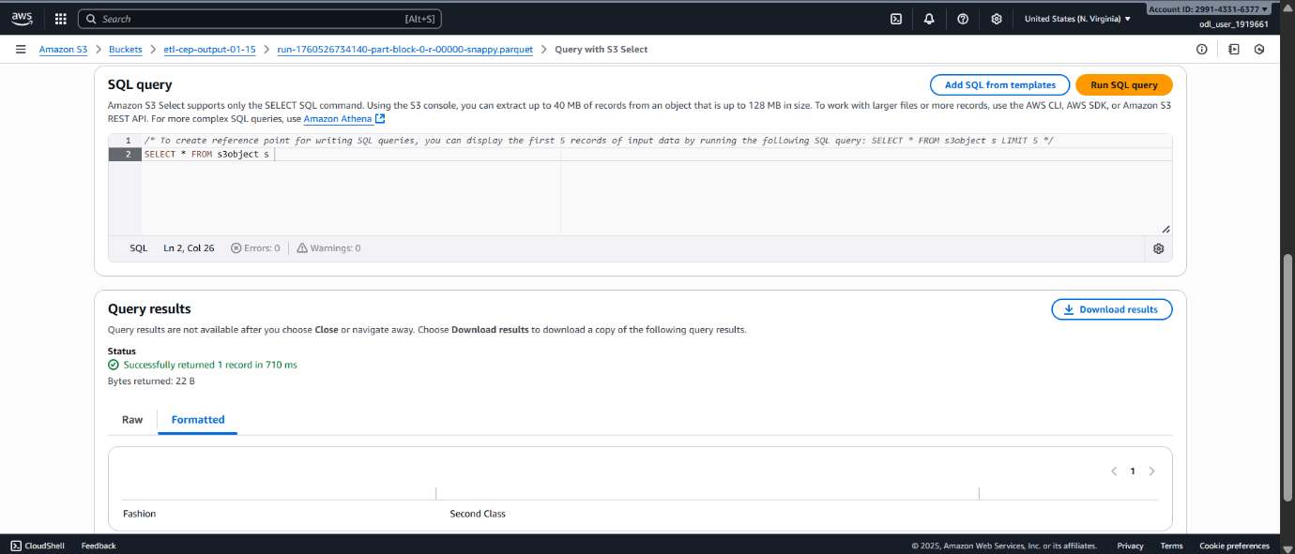
The output presented here has been obtained from the provided datasets.

